**11/29/2017**

**Head First Design Patterns**

**Project 4 Report**

***Braeden Brettin, Matthew Deremer, and Luke Pace***

**Table of Contents**

Table of Figures 3

Adapter Pattern 6

Composite Pattern 15

State Pattern 27

Proxy Pattern 36

References 45

# **Table of Figures**

Figure 1. Adapter Design 6

Figure 2. Adapter and Target Design 7

Figure 3. Initial Failed Test 8

Figure 4. Initial Dog Class 8

Figure 5. Initial Beagle Class 9

Figure 6. Initial Wolf Class 9

Figure 7. Initial WildWolf Class 10

Figure 8. WolfAdapter Class 11

Figure 9. Refactored Wolf Class 11

Figure 10. Refactored WildWolf Class 12

Figure 11. Refactored Dog Class 12

Figure 12. Refactored Beagle Class 13

Figure 13. Successful Test 14

Figure 14: Visualization of Composite Pattern 16

Figure 15: Composite Pattern Class Diagram 17

Figure 16: Freestyle Coke Model 17

Figure 17: Failed Test 18

Figure 18: Initial Abstract Class 19

Figure 19: Initial Leaf Classes 19

Figure 20: Initial Composite Class 20

Figure 21: Abstract Class 21

Figure 22: Concrete Classes 22

Figure 23: Composite Classes 23

Figure 24: Composite Root Class 23

Figure 25: Composite Pattern Main 24

Figure 26: Composite Pattern Output 24

Figure 27: Passed Test 25

Figure 28. State Pattern Class Diagram 27

Figure 29. Diagram Sketch 28

Figure 30. GuestState Interface 29

Figure 31. RoamingInPark Class 30

Figure 32. InQueue Class 31

Figure 33. OnRide Class 32

Figure 34. ParkGuest Class 33

Figure 35. Test Code 34

Figure 36. State Pattern Output 35

Figure 37: Proxy Pattern UML Diagram 36

Figure 38: Proxy Test Suite 37

Figure 39: Subject Class 38

Figure 40: RealSubject Class 38

Figure 41: Proxy Class 39

Figure 42: Implemented Subject Class 40

Figure 43: Implemented RealSubject Class 41

Figure 44: Implemented Proxy Class 42

Figure 45: Proxy Pattern Main 43

Figure 46: Proxy Pattern Output 43

Figure 47: Successful Proxy Pattern Test 44

# **Adapter Pattern**

The object-oriented notion of an adapter is not too different from that of a real-life adapter. Think back to any trip you may have made to a foreign country. In most other countries, a normal AC plug will not connect to wall outlets. Why is this? It could be due to a difference in required voltage or a difference in socket design. How did you fix the problem? You used an adapter. This adapter adapted your design (the American AC plug) to a client (the wall outlet) without changing either of these components. In much the same way, object-oriented adapters provide functionality to connect an existing system to a client without changing the code of either of these components. Instead, new code is written in the adapter to adapt the two components. This adaptation can be visualized as a jigsaw puzzle, as shown in Figure 1, below.



Figure 1. Adapter Design

The adapter pattern “converts the interface of a class into another interface the clients expect” [1]. This pattern enables classes to work in tandem that otherwise would not be able to because of incompatible interfaces. This pattern also preserves the decoupling of the adapter and the client. Neither class has any knowledge of the inner workings of the other class, an ideal condition in object-oriented design. The client sees only the Target interface, and all requests get delegated to the Adaptee, as shown in Figure 2, below.



Figure 2. Adapter and Target Design

For the purposes of this project, I will create a Wolf interface that can be adapted to a Dog interface. Considering the close genetic relationship between these two species, these two animals share similar attributes and behaviors. As such, these two interfaces will share similar functions to replicate the real-world behaviors of these two species. The Dog interface contains functions for barking and running, bark() and run(), respectively. The Wolf interface contains functions for howling and running, howl() and run(), respectively. The bark() and howl() functions will differ slightly in the sound that the animal makes. The run() functions in the two classes will differ slightly in the amount of time that the animal runs. We have also created two concrete classes, each implementing either the Dog or Wolf interface.

A test suite was created that outlines the specific functionality we hope to achieve in this project. This test suite was purposefully failed, as shown in Figure 3, below.

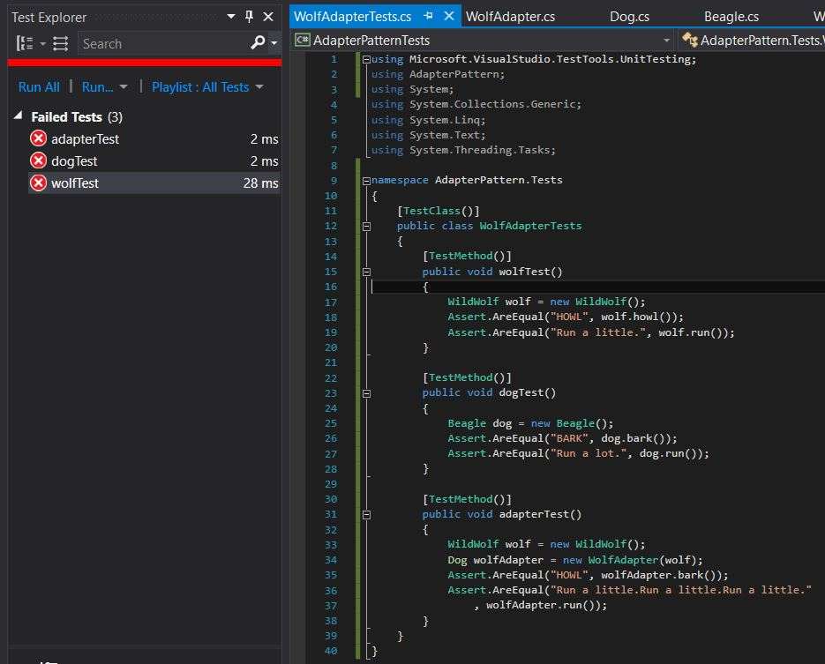

Figure 3. Initial Failed Test

The code in the interfaces and concrete classes at the time of this failed test was as shown in Figures 4 through 7, below.

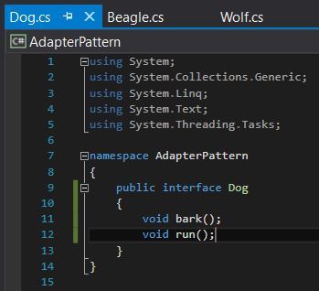

Figure 4. Initial Dog Class

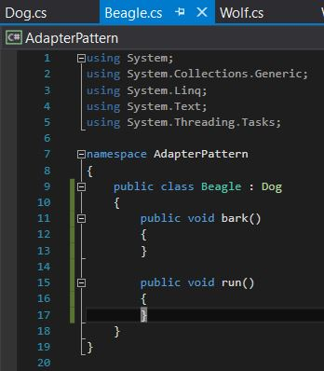

Figure 5. Initial Beagle Class

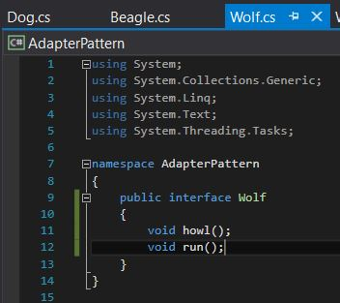

Figure 6. Initial Wolf Class

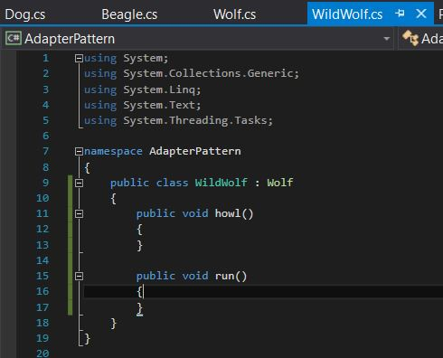

Figure 7. Initial WildWolf Class

Now that these initial classes have been created and the test suite created and outlined, we need to create an adapter for the Wolf interface. How do we go about doing so? We can examine the differences between dogs and wolves to create this adapter. Wolves hunt in packs, so they do not have to run for long periods of time like dogs must. The pack mentality and organization of wolves allows them to conserve energy when hunting. As such, they merely need to run in short spurts. In To to adapt a wolf to a dog, we need to call the wolf’s run() function multiple times to replicate the dog’s run() function, as shown in Figure 8, below.

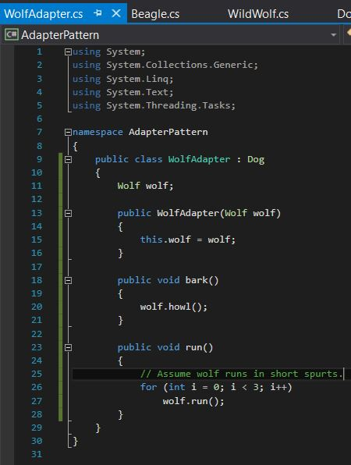

Figure 8. WolfAdapter Class

This adapter now provides the needed functionality to adapt a wolf to a dog and replicate the dog class’s behavior. We now merely need to update the Wolf, WildWolf, Dog, and Beagle classes to return the correct output when their respective functions are called, as shown in Figures 9 through 12, below.

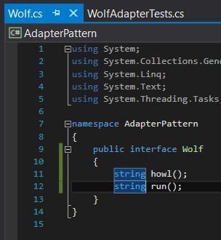

Figure 9. Refactored Wolf Class

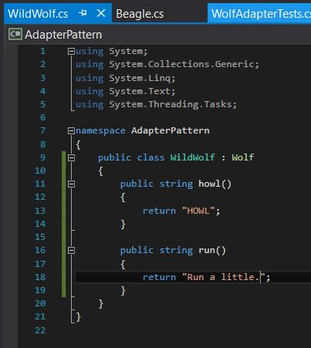

Figure 10. Refactored WildWolf Class

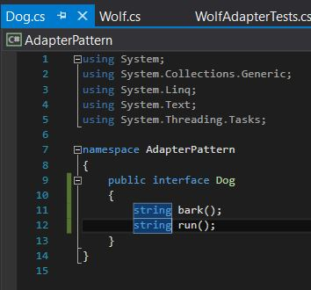

Figure 11. Refactored Dog Class

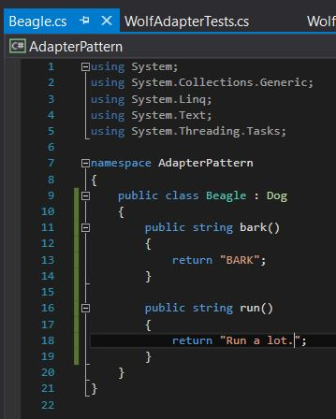

Figure 12. Refactored Beagle Class

With these classes refactored, we need to ensure that these changes result in successful tests, preserving the functionality of the project. The test suite was run again, producing the successful output shown in Figure 13, below.

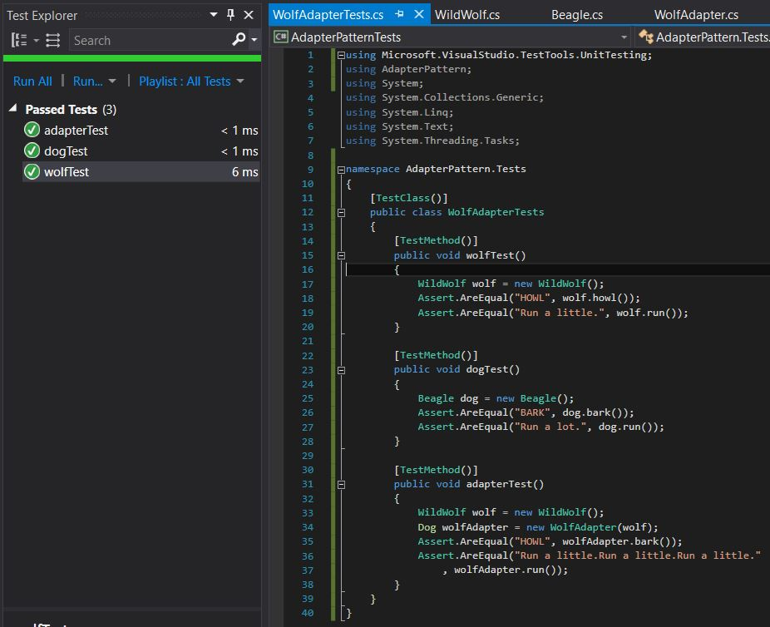

Figure 13. Successful Test

As can be seen from this project, object-oriented adapters can be used to adapt one interface to another without needing to change the code of either interface. The adapter pattern is extremely useful for adapting closely-related classes and has a plethora of real-world applications. When running low on objects of one class, consider using the adapter pattern to adapt this class to another class.

# **Composite Pattern**

The idea behind the use of the Composite Pattern can be seen all around us. For example, think about the last time you went to the doctor. You probably saw a nurse first who took some general information, then the doctor would perform an exam and the nurse may come back to finish the visit. Then you go to the lab to have some different readings taken and wait for the results. So now we have created a detailed hierarchy with lots of different objects that documents the visit. Then comes the important part, the bill. Billing does not care about the details of the visit, they just want to know what was done that is billable. To obtain this information with the current setup would be difficult because it is embedded in the records which is clogged up with different objects and is not always consistent with the hierarchy because each visit does not go through the same process. This issue of too many objects and an inconsistent graph of data can be solved by implementing the Composite Pattern. We could define a base class with a billing property and each encounter would appear as a container with the base class inside. Billing can now simply enumerate everything inside an encounter and not worry about if it is a node or leaf. Figure 14 shows a visualization of the organization of the data using the Composite Pattern where the composites are nodes (i.e., nurse exam, lab visit) and the leaves are information such as height and weight.

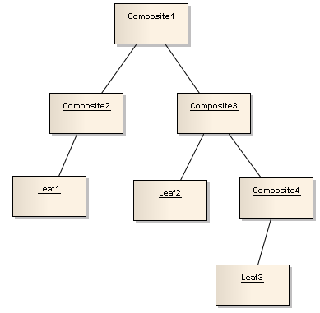

Figure 14: Visualization of Composite Pattern

The Composite Pattern “allows you to compose objects into tree structures to represent part-whole hierarchies. Composite lets clients treat individual objects and compositions of objects uniformly” [1]. What our text means by part-whole is the tree is composed of parts but can be treated as a whole. This can be very useful because it allows us to write simple code to apply an operation to the entire structure. Figure 15 shows the class diagram of the Composite Pattern.

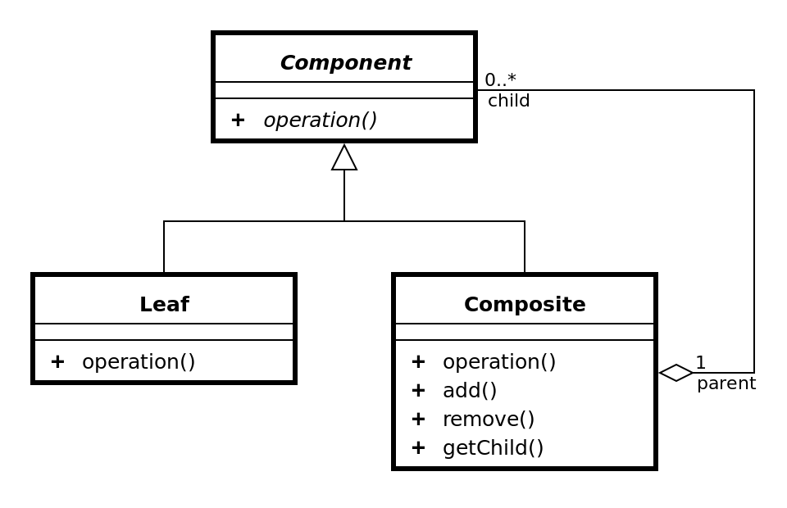

Figure 15: Composite Pattern Class Diagram

As the above figure shows, there are three components needed for the Composite Pattern. The first is the component which declares an interface for objects in the composition and implements behavior common to all objects. It also must implement an interface for adding and removing its own children. The second component is a leaf which implements the behavior for a leaf. The final component is a composite which defines behavior for nodes and implements the adding/removing interface from the component.

To model the Composite Pattern, we have implemented a Freestyle Coke machine which has a hierarchy of drinks starting with brand and working down to flavor. Figure 16, below, shows a model of the hierarchy.

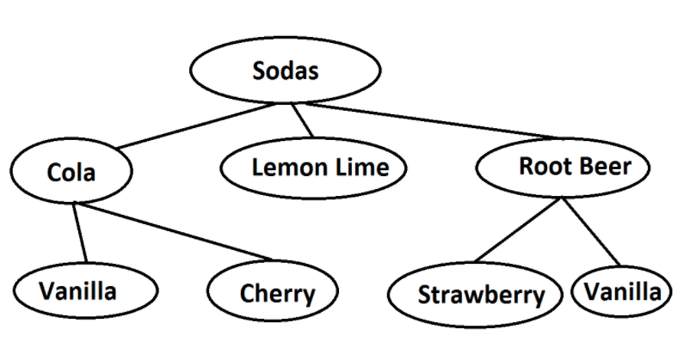

Figure 16: Freestyle Coke Model

A test suite was created to test the functionality we hoped to achieve which is shown in Figure 17, below.

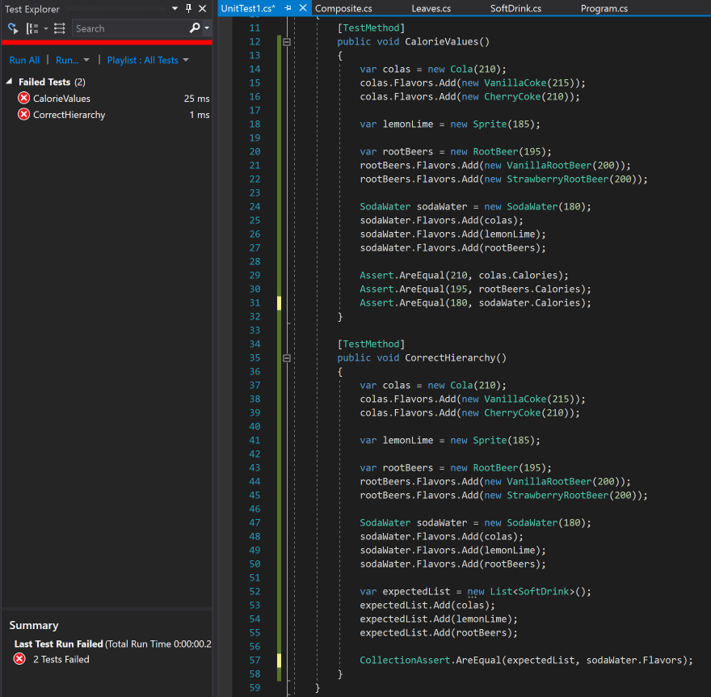

Figure 17: Failed Test

After creating the test suite, we created the outline for our abstract class to represent all soft drinks, the classes for different leaves, and the classes for composites. Figures 18 through 20 show the initial classes.

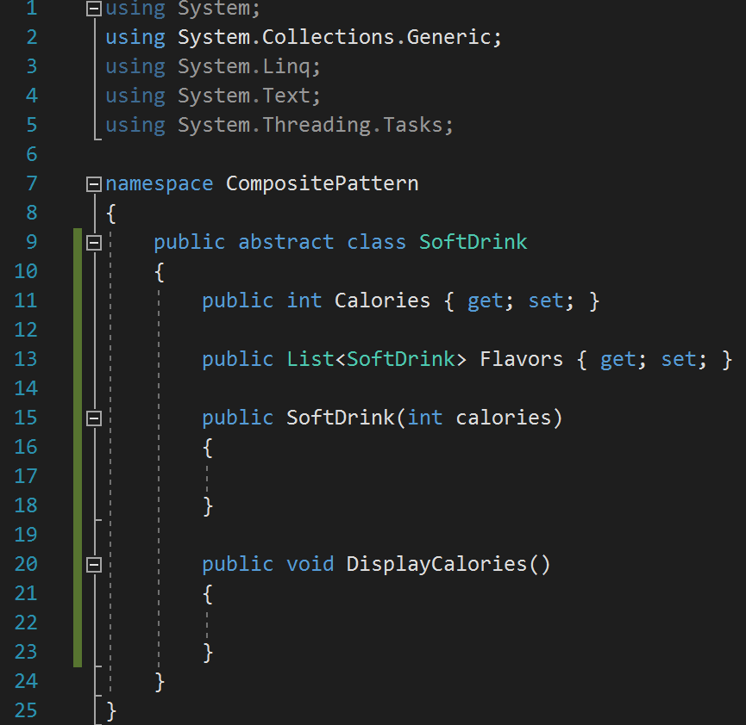

Figure 18: Initial Abstract Class

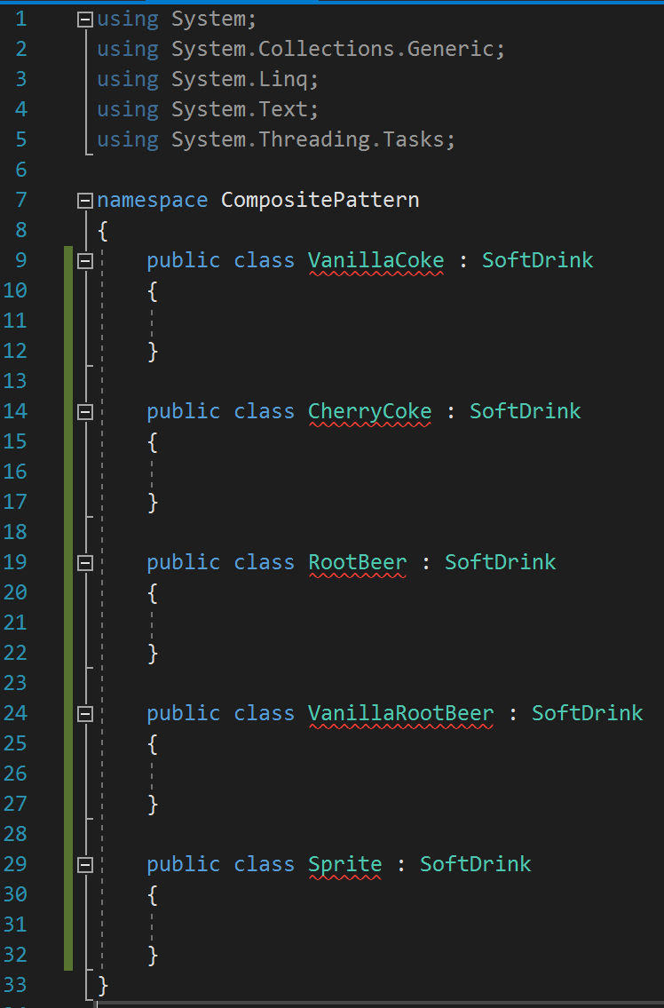

Figure 19: Initial Leaf Classes

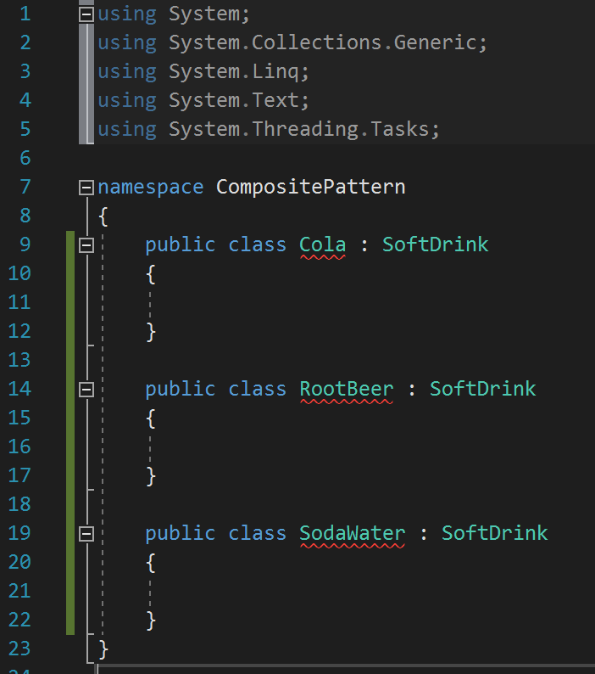

Figure 20: Initial Composite Class

We then needed to implement the abstract class which included a method, DisplayCalories(), that is recursively called to print the number of calories in a soda for each node. The class can be seen in Figure 21, below.

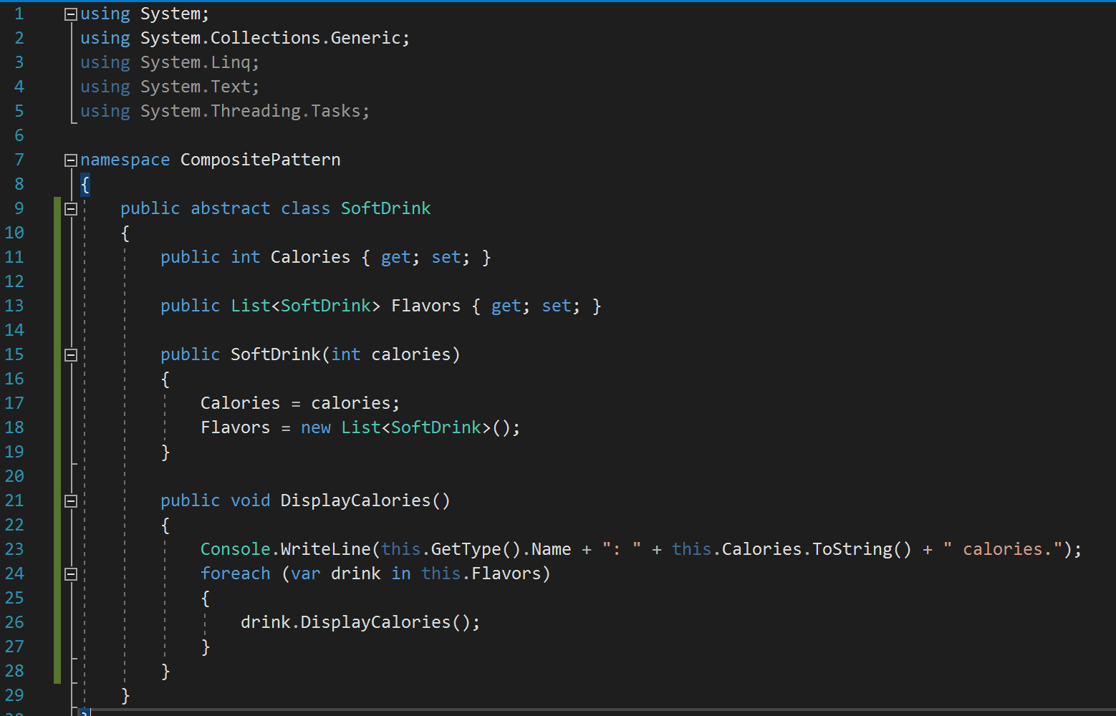

Figure 21: Abstract Class

We then implemented the concrete classes for the different soda flavors as shown in Figure 22, below.

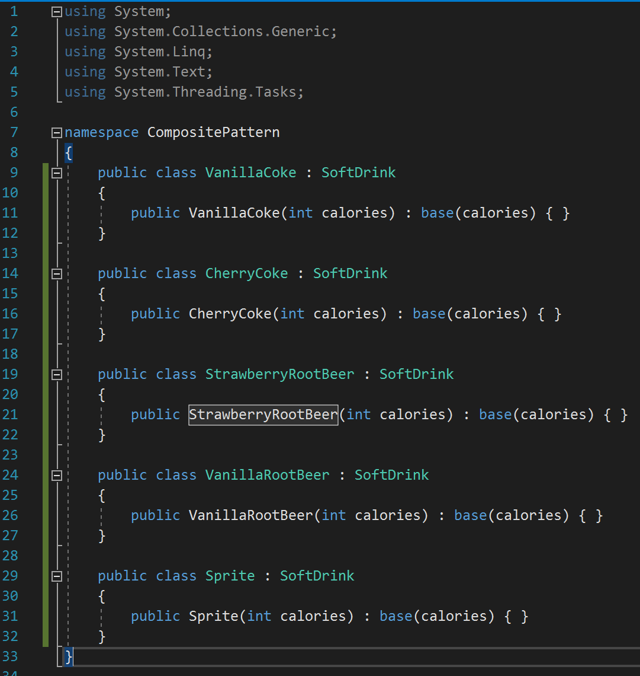

Figure 22: Concrete Classes

We then implemented the two composite components, Cola and RootBeer, which represent the objects with children as shown in Figure 23, below.

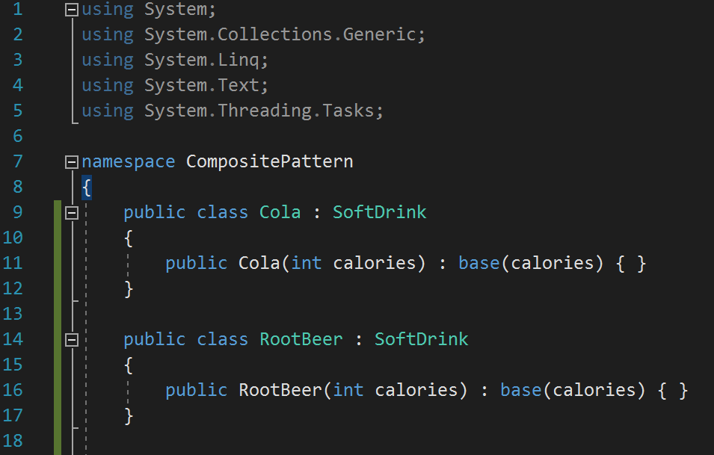

Figure 23: Composite Classes

The last component to be added is a composite class to be used as the root node shown in Figure 24, below.

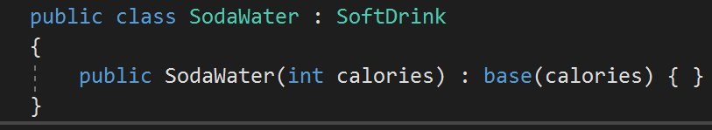

Figure 24: Composite Root Class

We could then utilize our hierarchy as shown in Figure 25 which yielded the output shown in Figure 26.

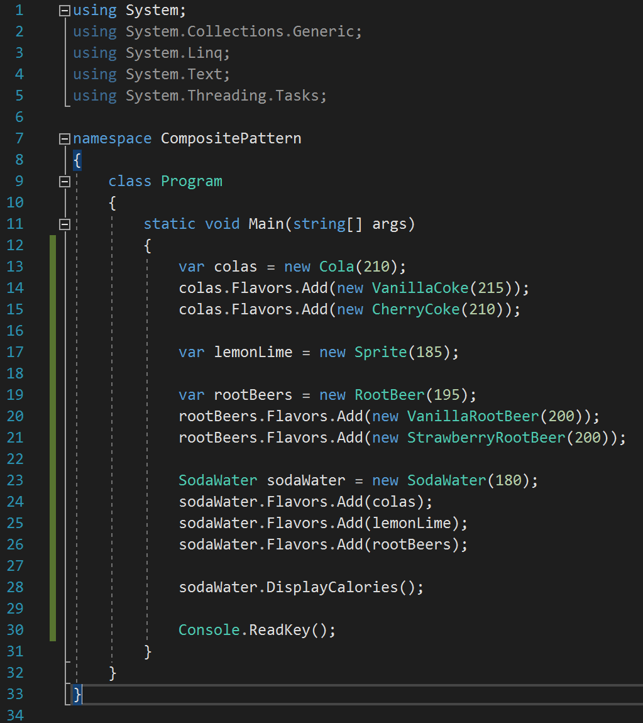

Figure 25: Composite Pattern Main

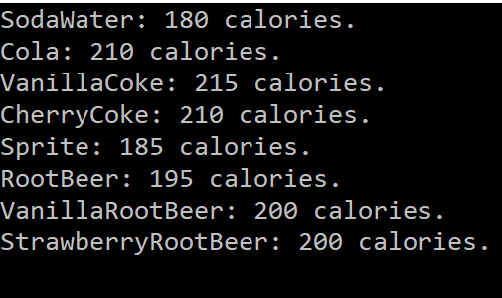

Figure 26: Composite Pattern Output

Now that all the classes have been implemented, we can run our test suite and see that all test pass as shown in Figure 27, below.

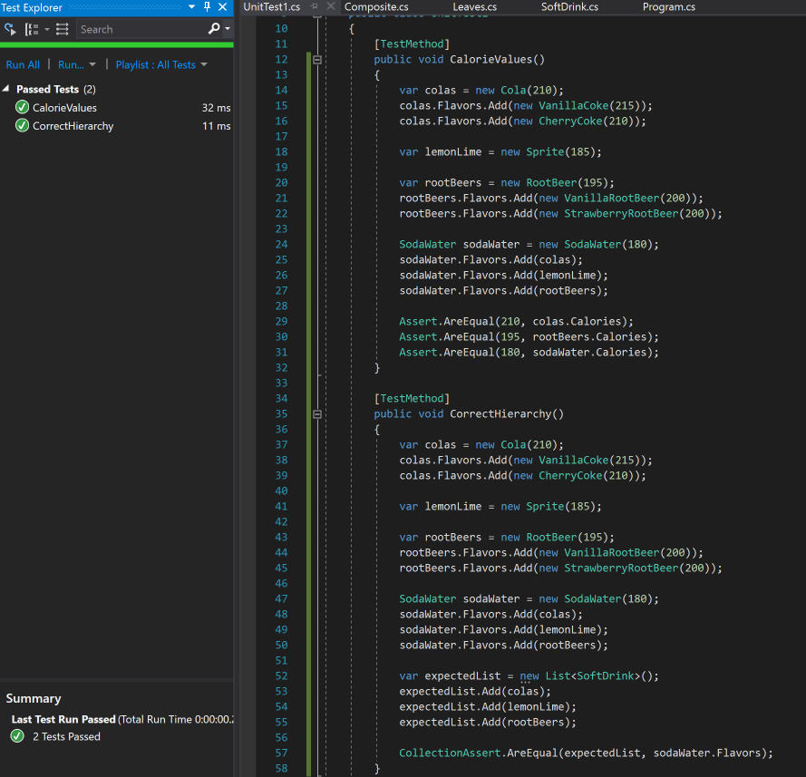

Figure 27: Passed Test

As seen from this section of the project, the Composite Pattern is a useful way to implement a hierarchy where the client can apply similar functions to all parts. Developers should be careful when using this pattern as to what design they follow, uniformity or type safety. Uniformity allows the client to treat leaves and composites the same but the type can be lost as a leaf can perform a function only a composite should. It is better to follow the type safety design as this project has which implements the leaves and composites separately therefore preserving the type.

# **State Pattern**

The State Design Pattern is used when there is one too many relationships between objects such that if one object is modified, its dependent objects are to be notified automatically. This pattern is used to alter the behavior of an object when its internal state changes. In this pattern, an object is created which represents various states and a context object whose behavior varies as its state object changes. See Figure 28 for the State Pattern class diagram.

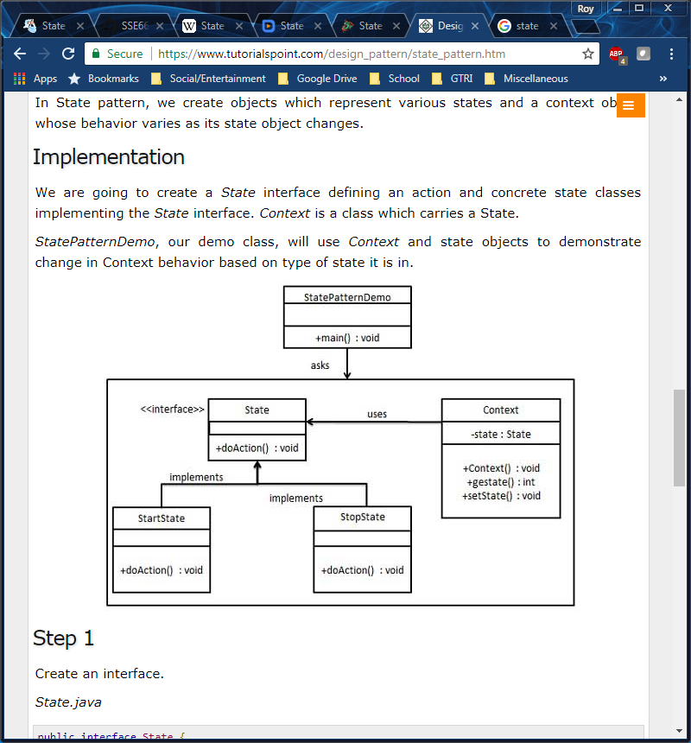

Figure 28. State Pattern Class Diagram

In the above diagram, the State interface defines an action and concrete classes to implement the State interface. Context represents a class which carries a State. The demo class, StatePatternDemo, uses Context and state objects to demonstrate change in Context behavior based on which state it is in.

Let’s begin creating our own example of a State Pattern. For this example, we will create a class named ParkGark that might be used in a theme park simulation video game. Let’s allow the park guest to have three different states: RoamingInPark, InQueue, and OnRide. To transition between states, we will write three methods: EnterQueue, GetOnRide, and ExitRide. See Figure 29 for a simple diagram of the three states and the required action to transition between each state.

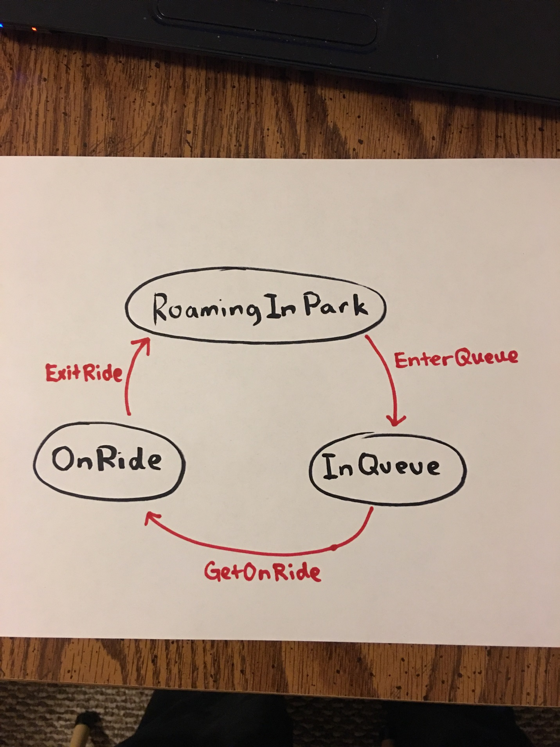

Figure 29. Diagram Sketch

It’s time to begin writing this in code. First, we will create an interface for the state. See Figure 30.

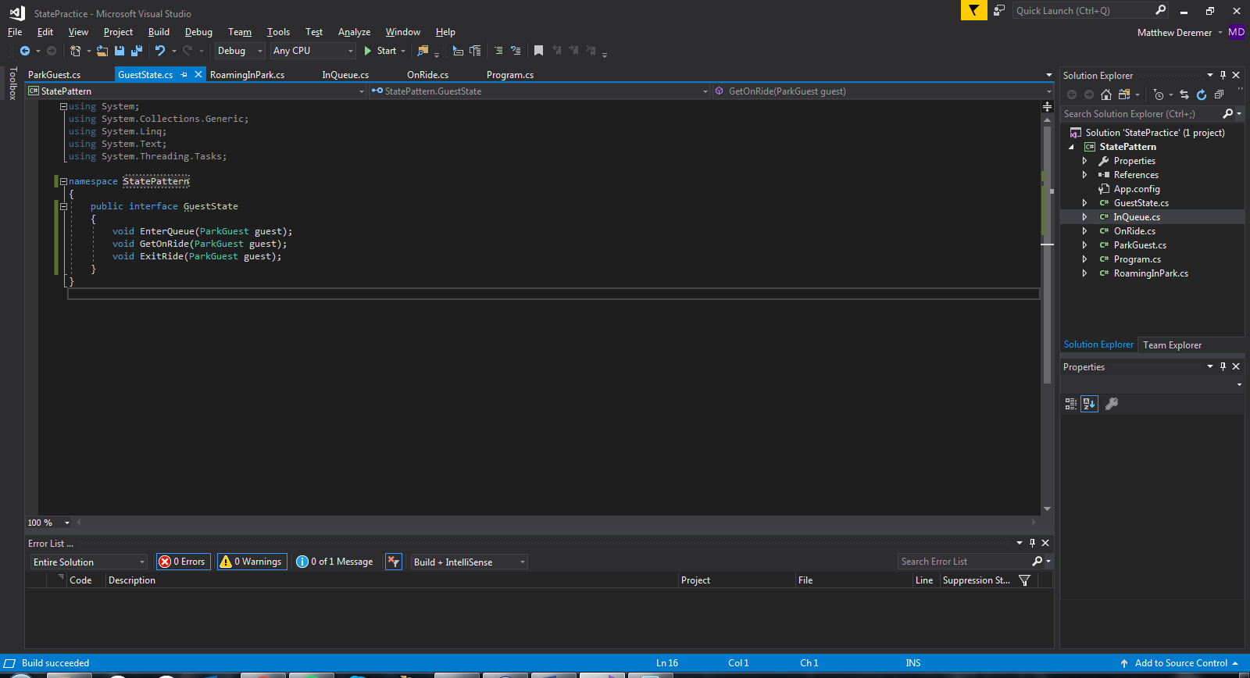

Figure 30. GuestState Interface

Let’s now create our three concrete classes to implement the state interface. See Figures 31 through 33.

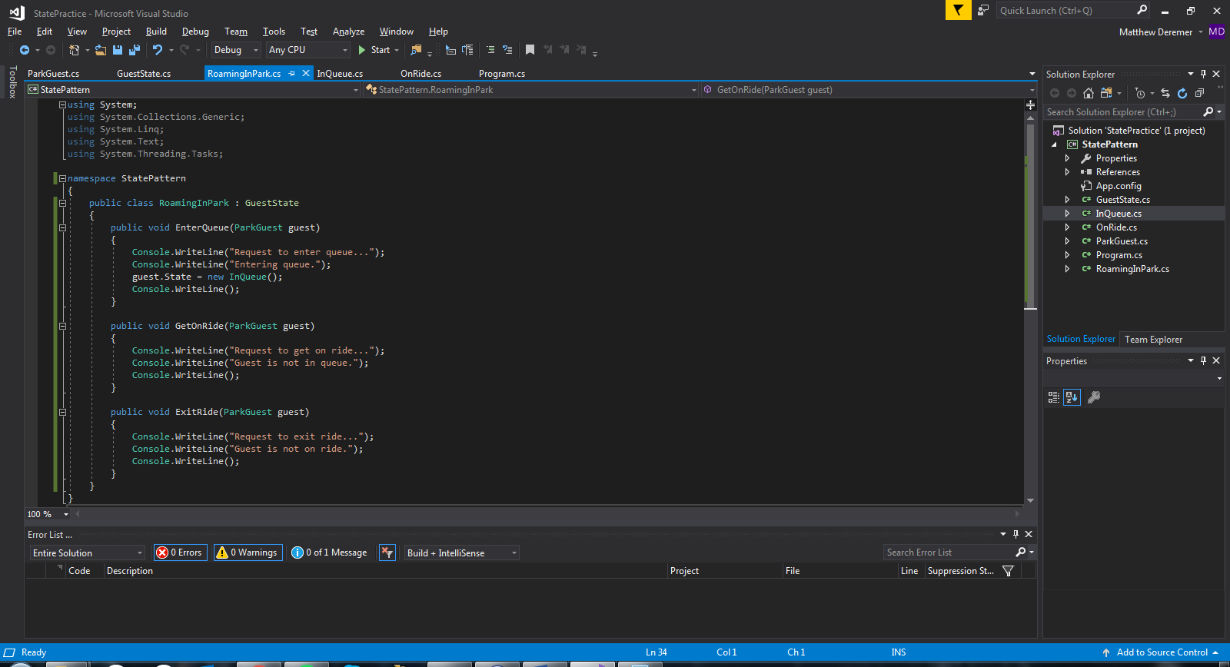

Figure 31. RoamingInPark Class

Notice how each method begins with a request. In the case of RoamingInPark, the only method that causes a state in change is the EnterQueue method. This causes a state in change from RoamingInPark to InQueue. The GetOnRide and ExitRide methods only return a message and do not result in a change of state.

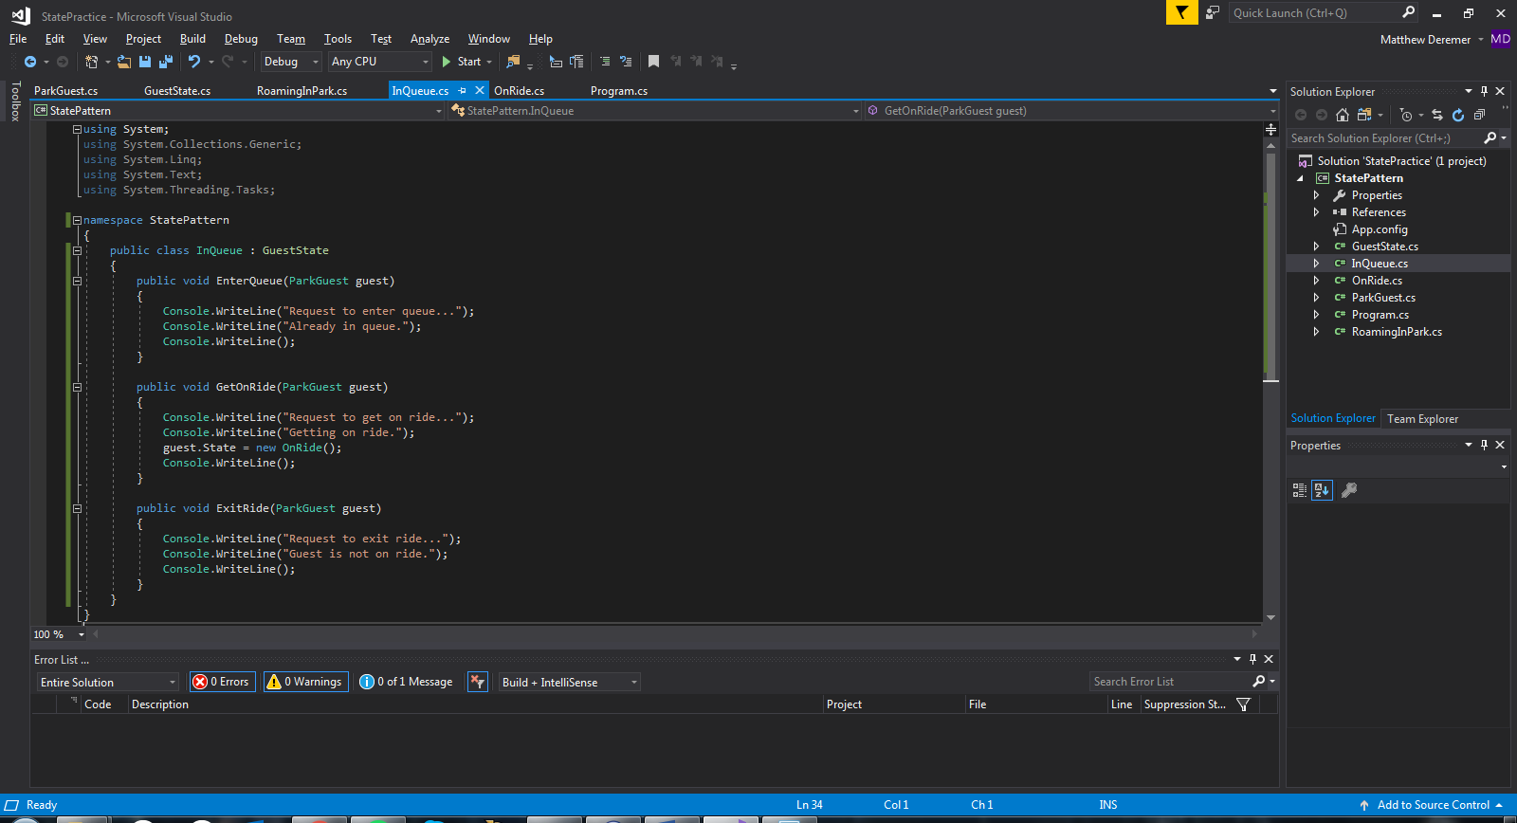

Figure 32. InQueue Class

In the InQueue class, the only method that causes a state in change is the GetOnRide method. This causes a state in change from InQueue to OnRide. The EnterQueue and ExitRide methods only return a message and do not result in a change of state.

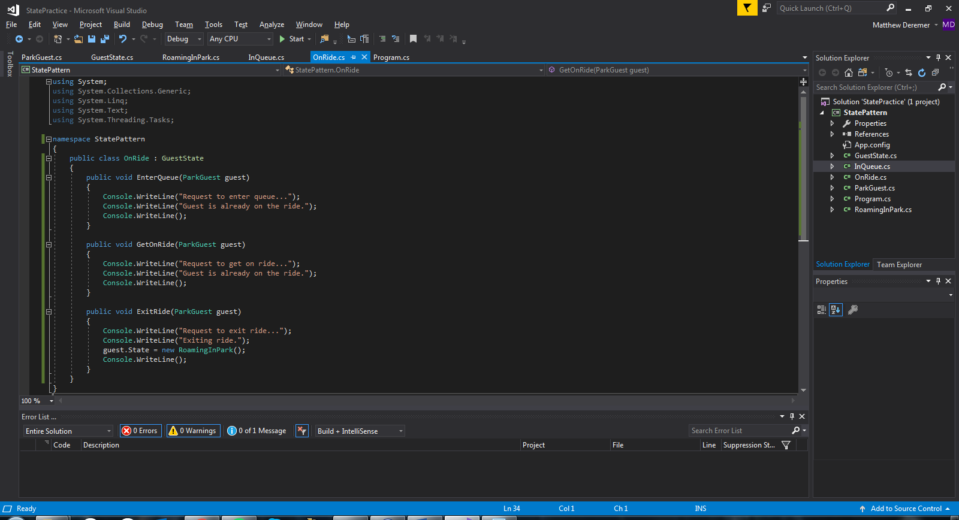

Figure 33. OnRide Class

In the OnRide class, the only method that causes a state in change is the ExitRide method. This causes a state in change from OnRide to RoamingInPark. The EnterQueue and GetOnRide methods only return a message and do not result in a change of state.

Now we need to create the ParkGuest Class as shown in Figure 34, below.

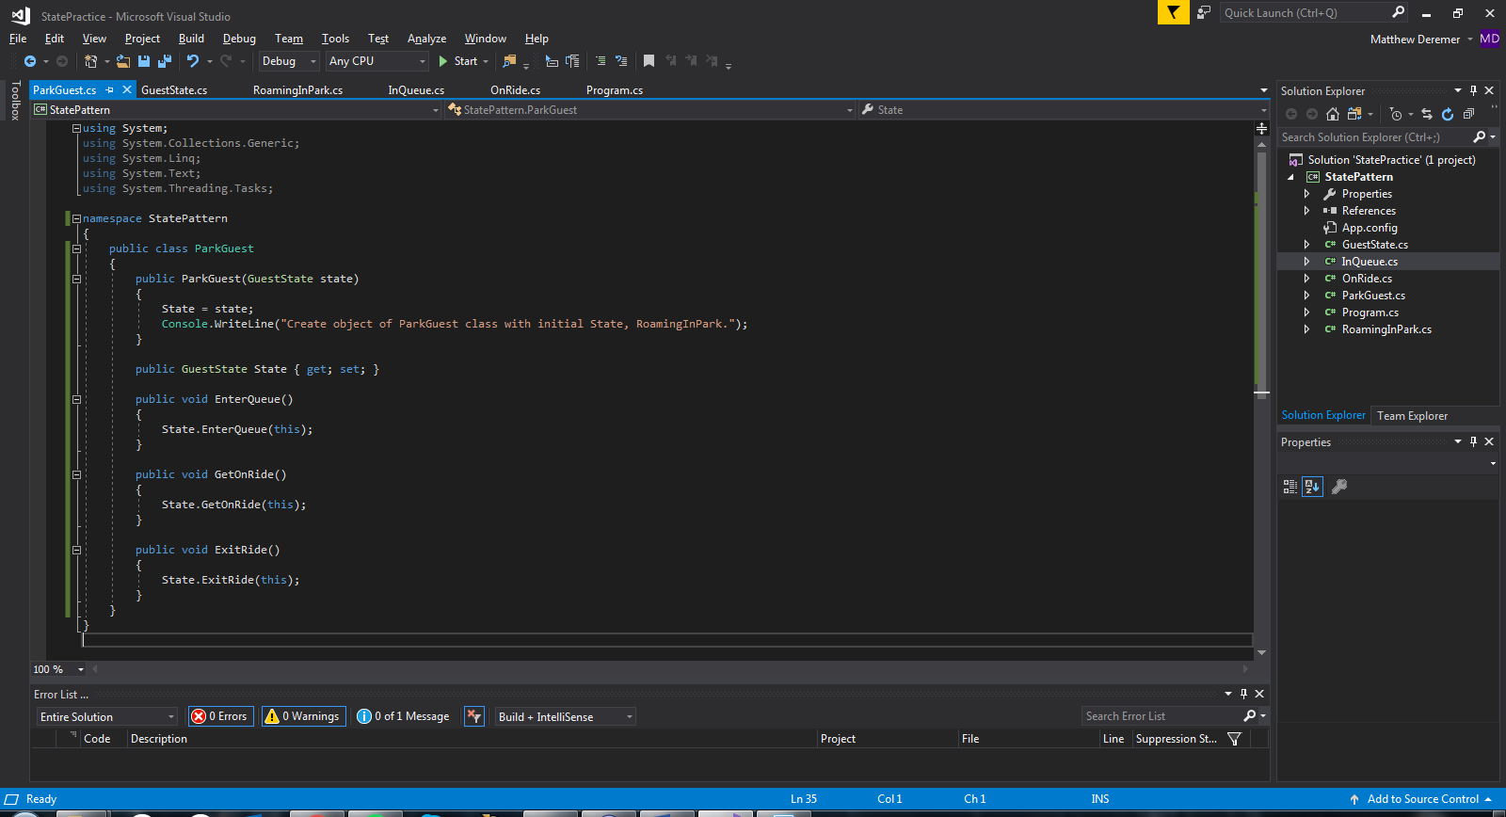

Figure 34. ParkGuest Class

Now that all our classes have been created, we can write code to test the behavior when GuestState changes. Follow along between the code and the output to verify it works properly. See Figure 35 and Figure 36.

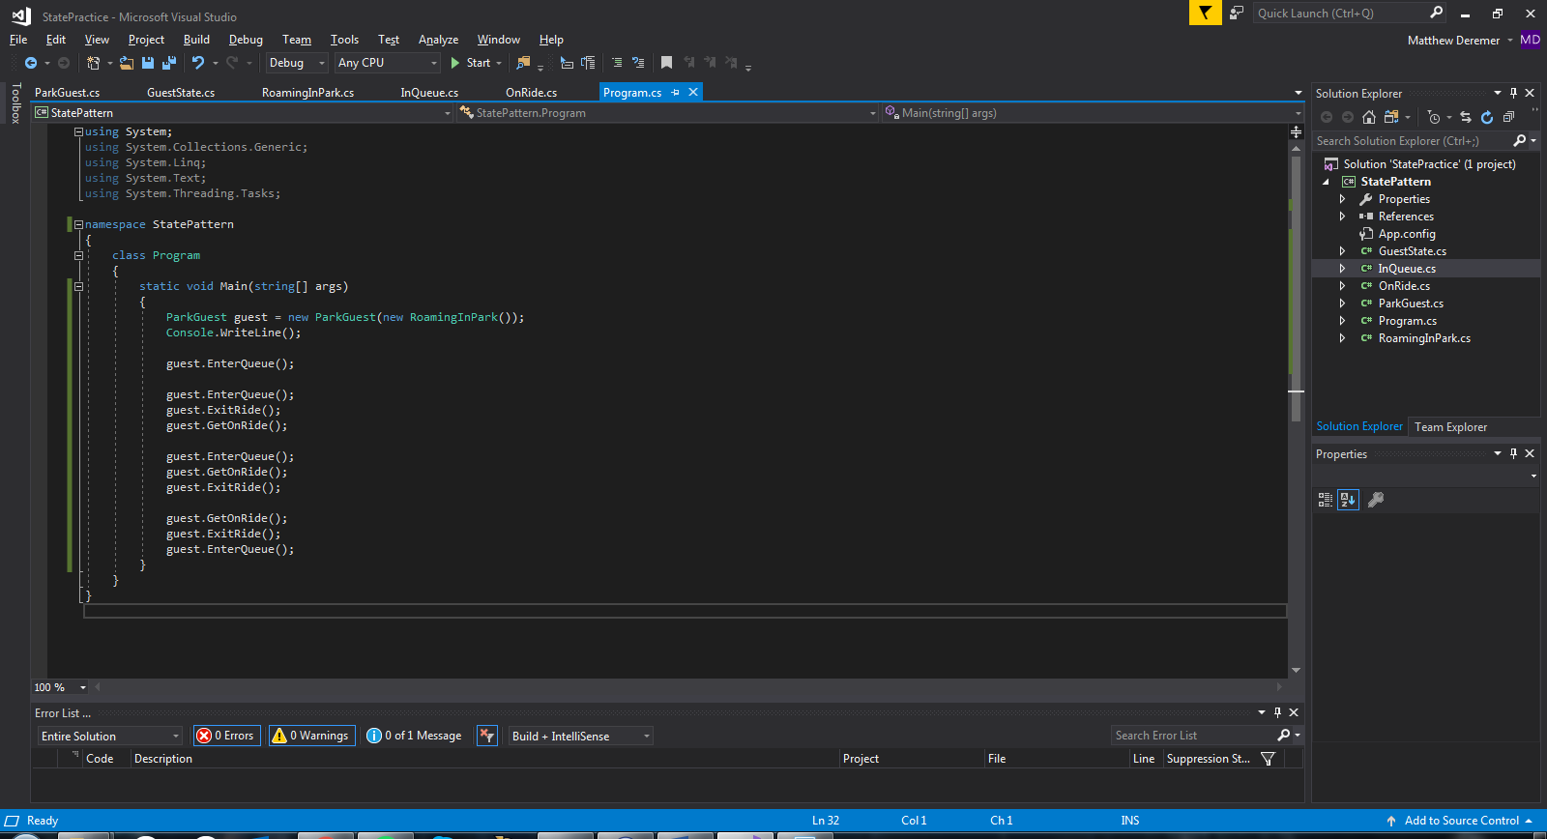

Figure 35. Test Code

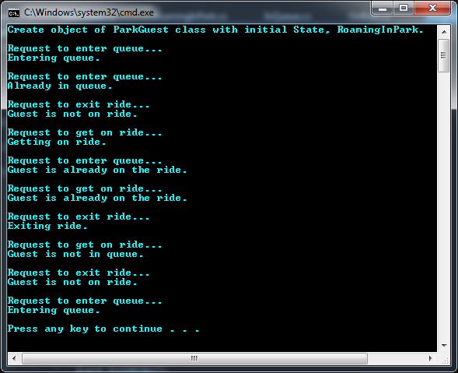

Figure 36. State Pattern Output

The output shows each requested action and the result of the request. The code performs as expected, only changing state based on the sketched diagram in Figure 29.

# 

# **Proxy Pattern**

We’ve all seen examples of the proxy pattern even if we didn’t know it at the time. For example, take a receptionist. When you contact an office in search of an employee, the receptionist answers the call. The receptionist can perform many of the same actions as the employee, such as answering the call, setting up meetings, and providing information about the company. However, the receptionist cannot do everything the employee can do. In this case, the receptionist must make a request to the employee for the desired action. In this way, the receptionist acts as a proxy for the employee. See Figure 37, below, for the UML diagram of the Proxy Pattern.

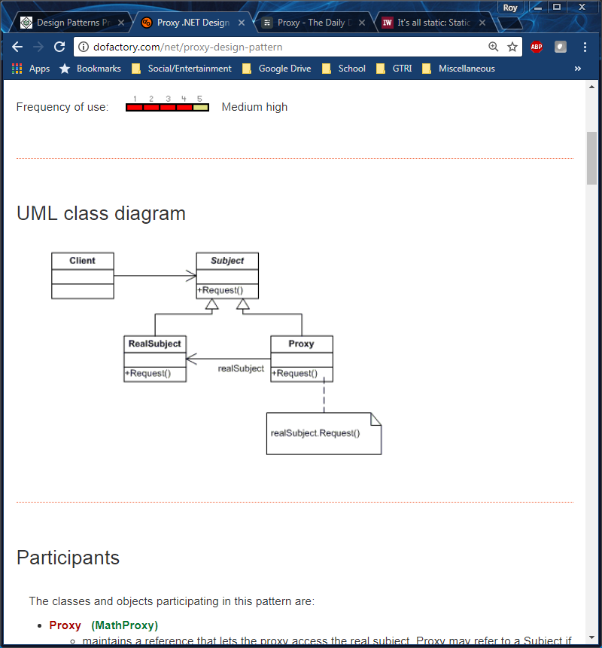

Figure 37: Proxy Pattern UML Diagram

For the given example, the receptionist acts as the Proxy while the employee acts as the RealSubject. The Proxy Pattern is useful because it controls who or what has access to an object. Additional functionality is then added when access to the object is granted. This pattern is practical in the real world because it can limit access to a server.

To demonstrate the Proxy Pattern, we have designed a waiter application where an experienced waiter will serve as the RealSubject and a training waiter will be the Proxy. We also have an interface to connect the RealSubject and Proxy which will be the Subject. Before setting up the classes, we wrote a test suite which can be seen in Figure 38, below.

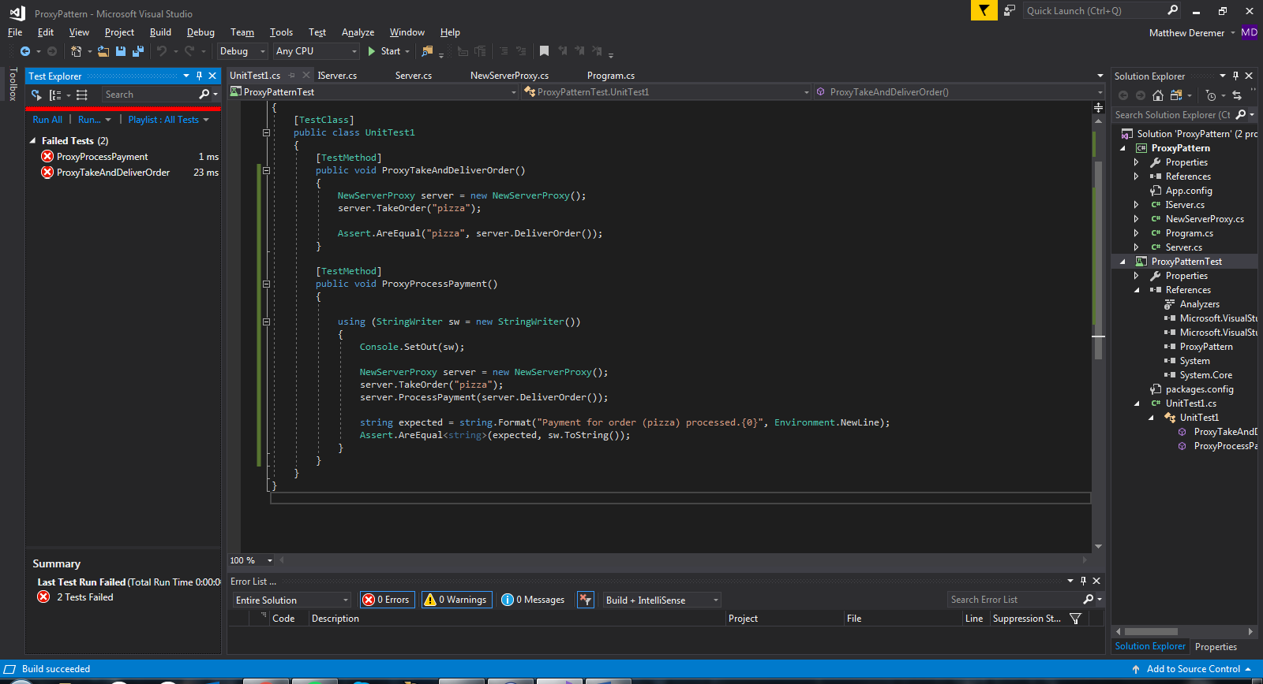

Figure 38: Proxy Test Suite

After writing the test suit, we outlined the Subject, Proxy, and RealSubject classes which can be seen in Figures 39 through 41, below.

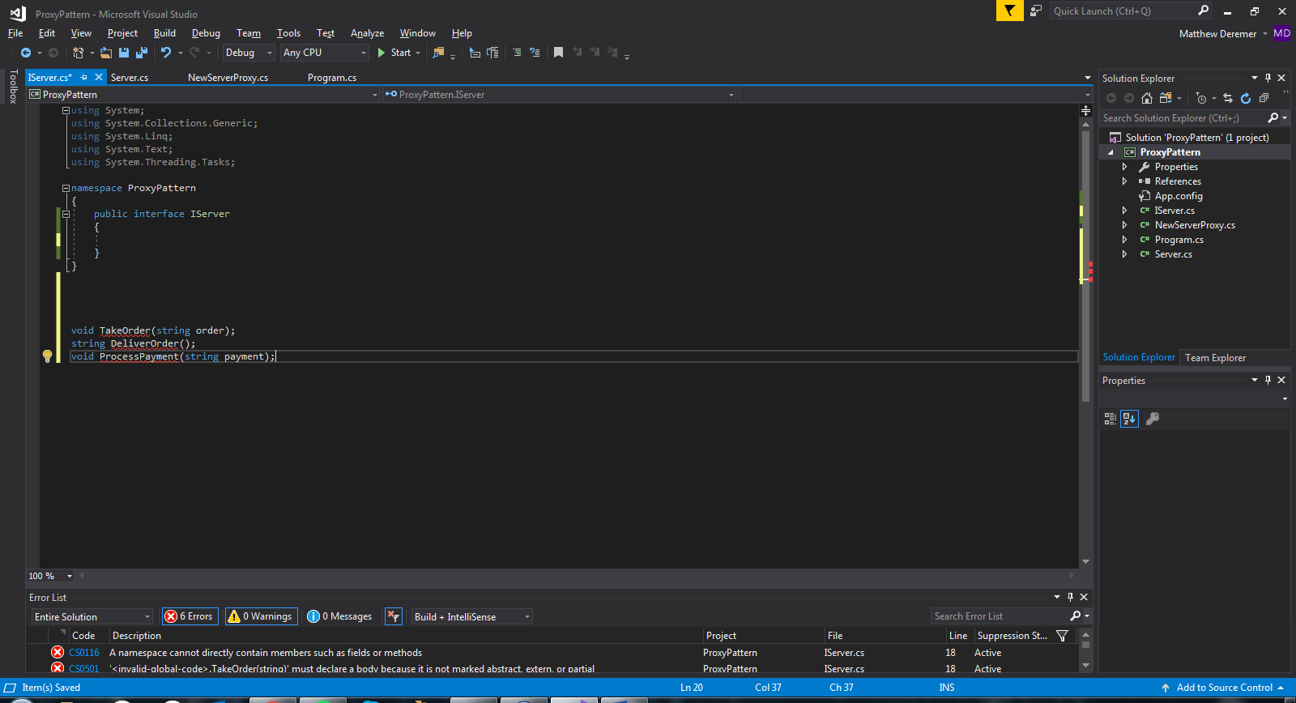

Figure 39: Subject Class

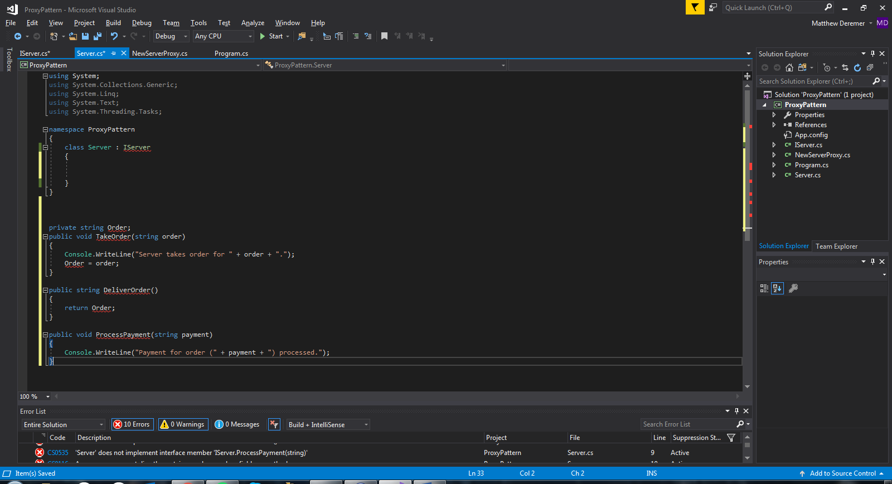

Figure 40: RealSubject Class

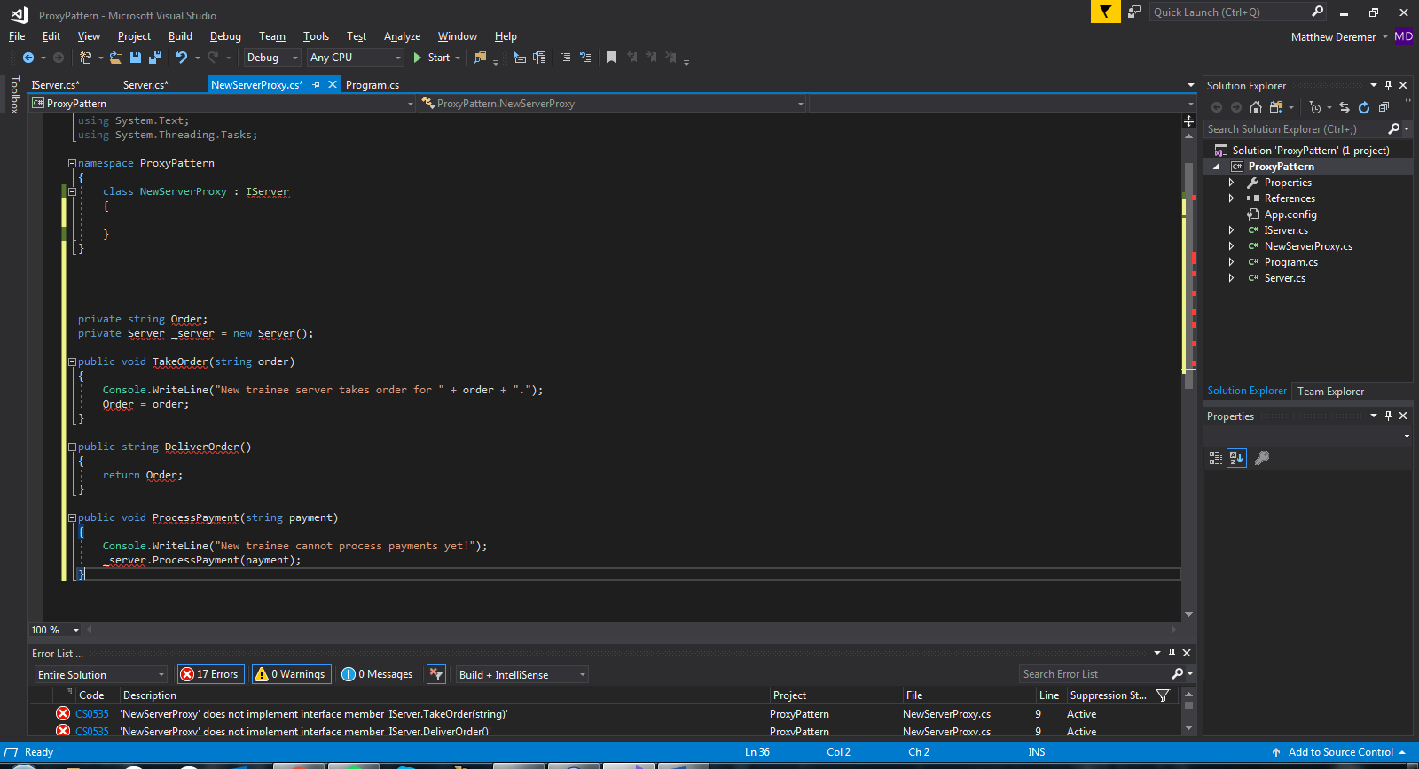

Figure 41: Proxy Class

After outlining each class, we needed to implement the interface that would be used to connect the RealSubject and Proxy together. As seen in Figure 42, below, the interface has three methods. TakeOrder(), DeliverOrder(), and ProcessPayment(). The Proxy can take and deliver an order but cannot process a payment. Only the RealSubject can process a payment. The implementations of the Proxy and RealSubject will be shown next.

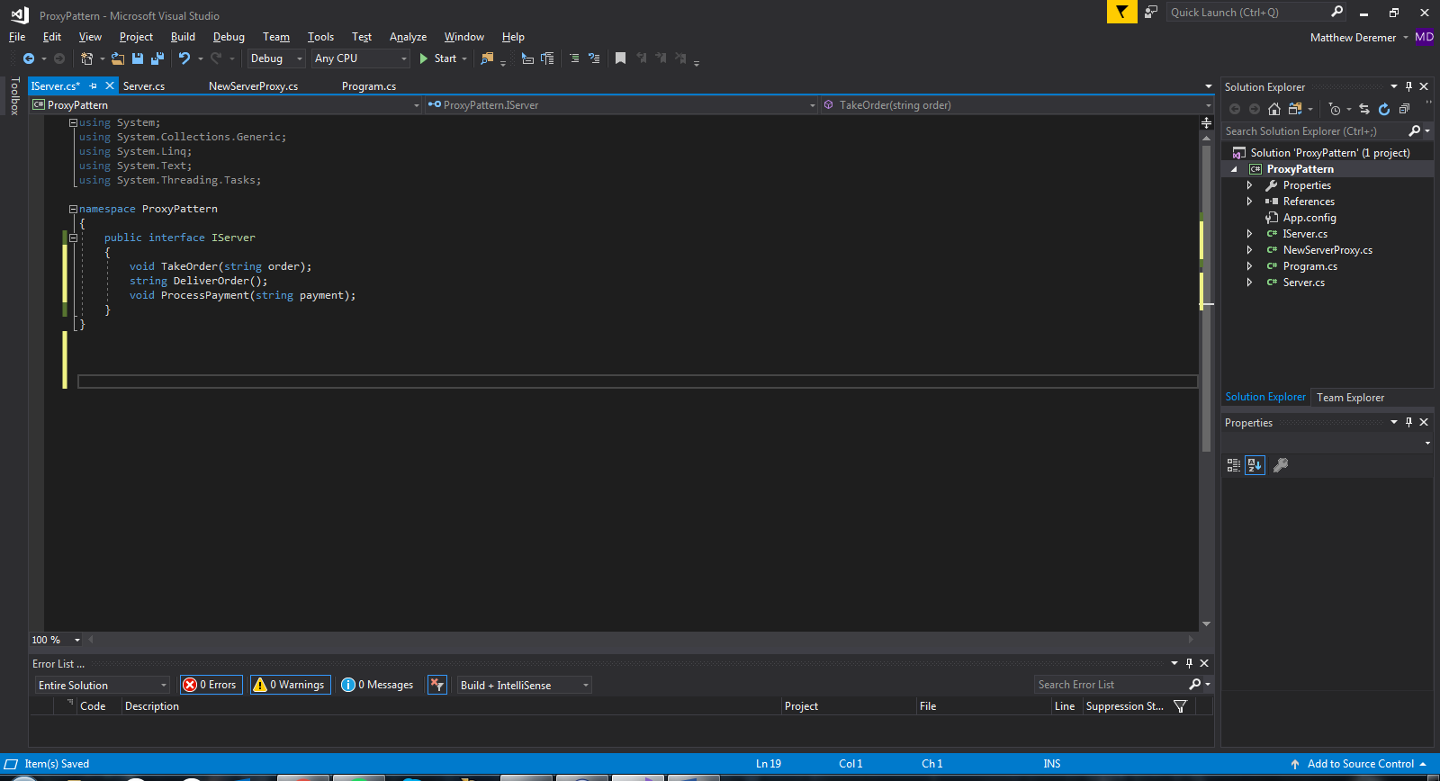

Figure 42: Implemented Subject Class

Once the interface or Subject had been implemented, we wrote the code for the server or RealSubject. As shown in Figure 43, below, the server implements all the methods of the interface.

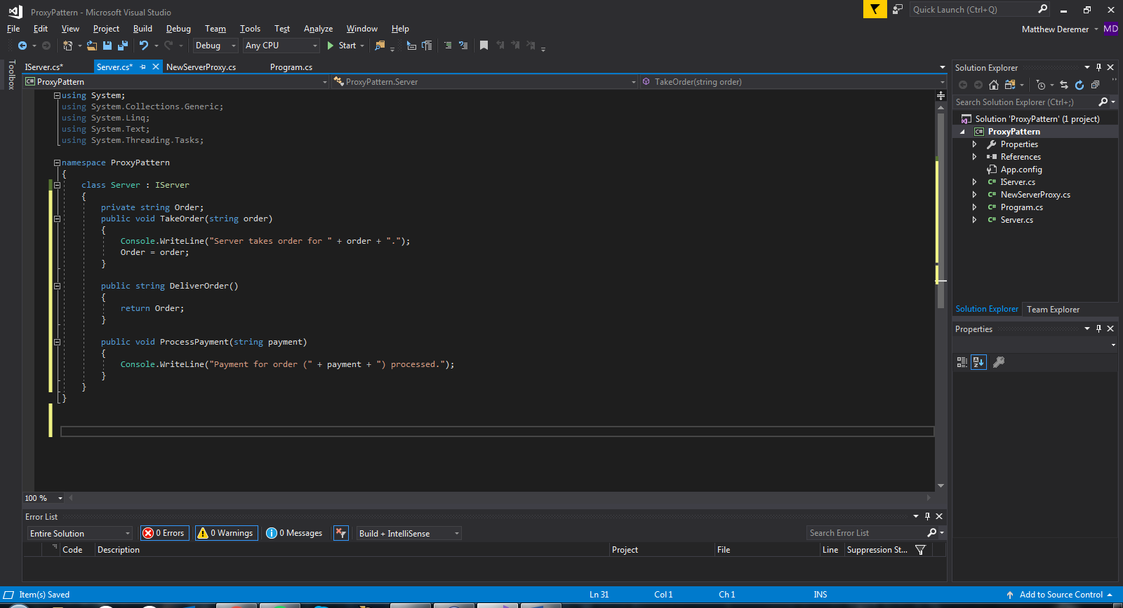

Figure 43: Implemented RealSubject Class

The final class for the Proxy Pattern is the new server or Proxy. As shown in Figure 44, below, the Proxy implements its own TakeOrder() and DeliverOrder() but when ProcessPayment() is called, it must create a server object.

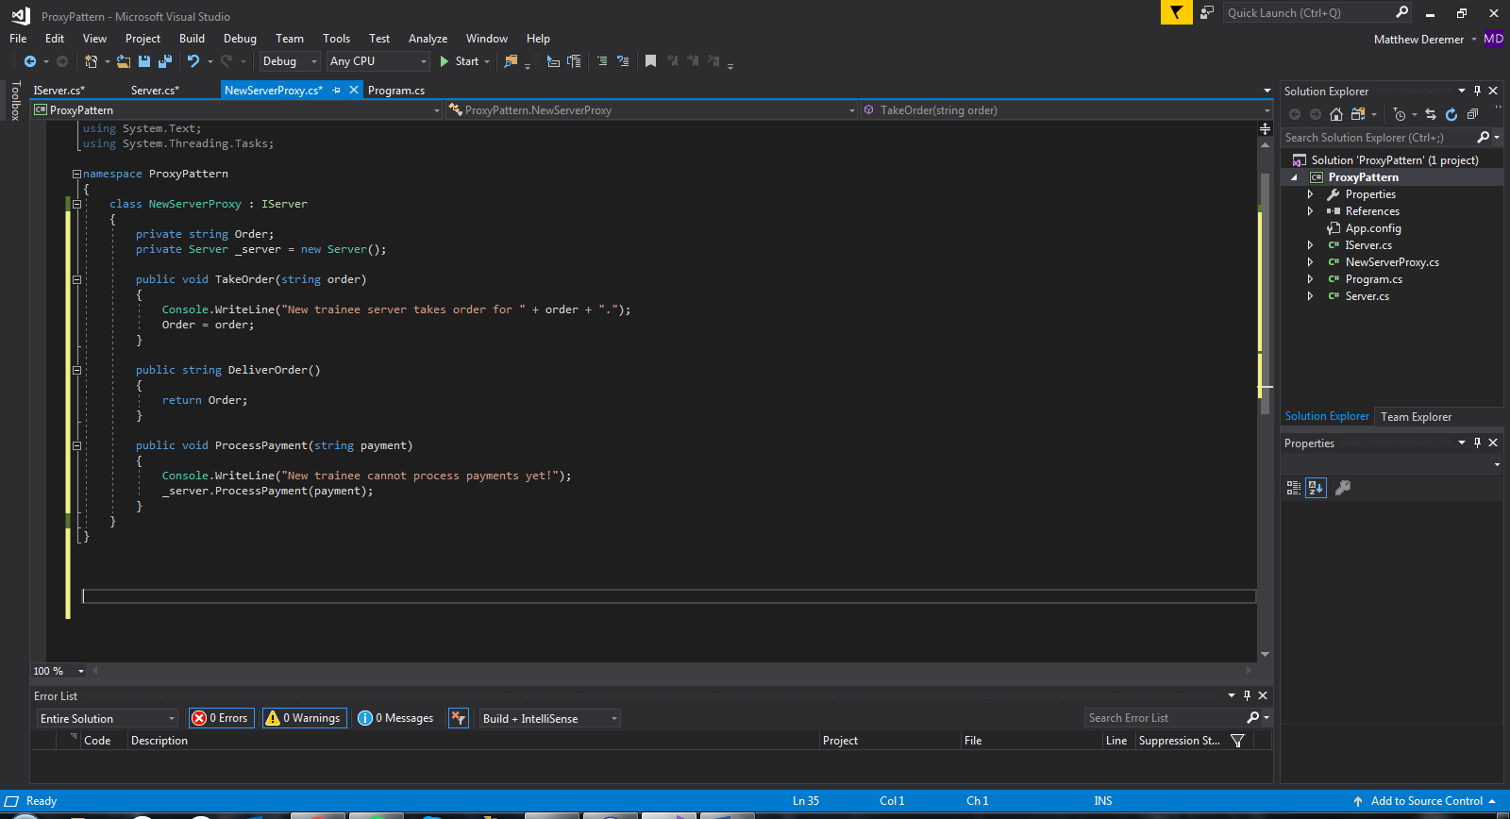

Figure 44: Implemented Proxy Class

After finishing setting up our Proxy Pattern, we wrote a main method to demonstrate the pattern and write our output to the command prompt. See Figure 45, below, for the main method.

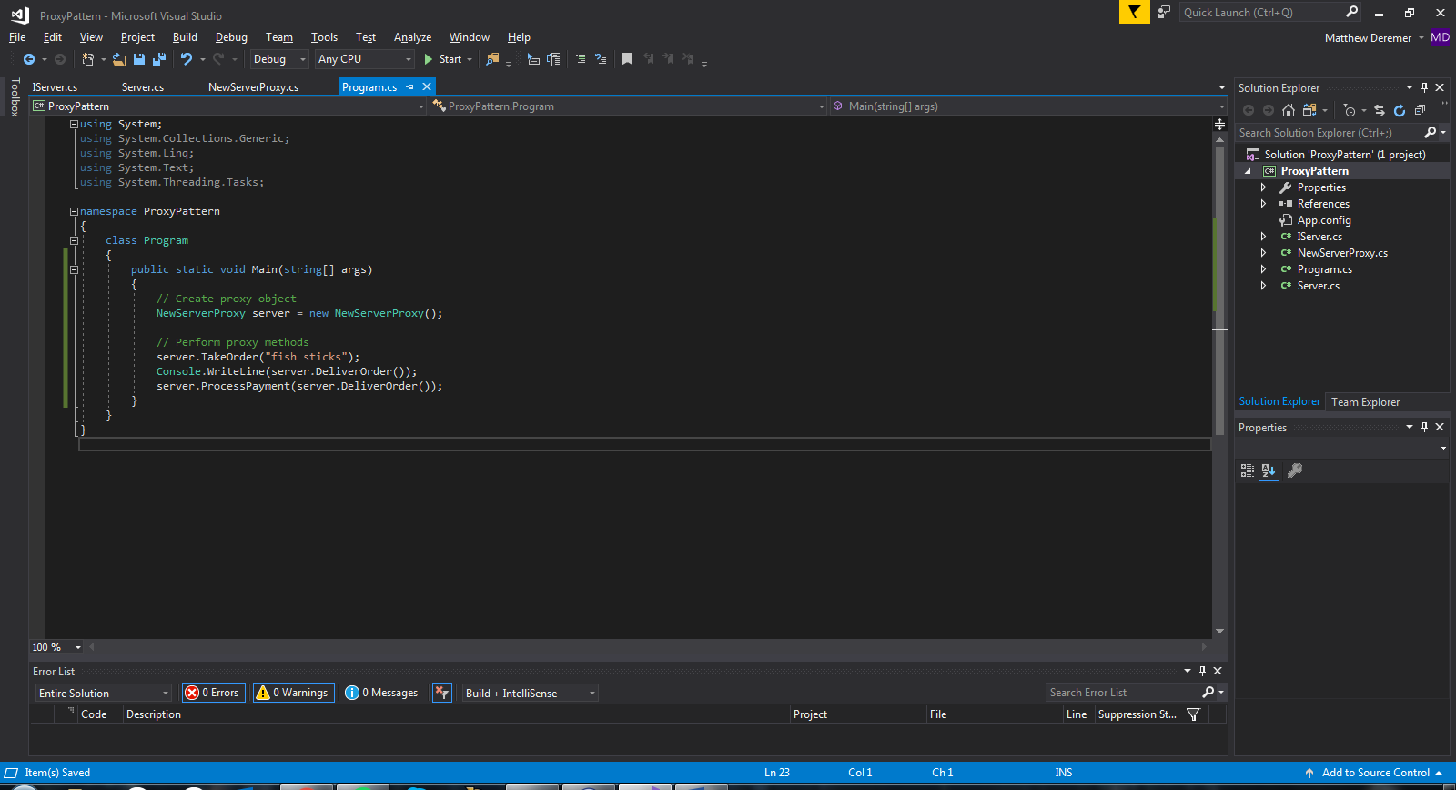

Figure 45: Proxy Pattern Main

We started by creating a NewServerProxy object. All three methods were called to show how the proxy object handled each request. Figure 46, below, shows the output and describes how the pattern handled these requests.

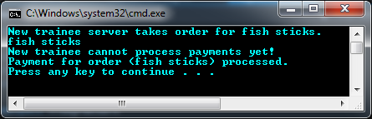

Figure 46: Proxy Pattern Output

The proxy object, *server*, was able to complete the TakeOrder method and return the order as a string in the DeliverOrder method. However, when we request *server* to perform the ProcessPayment method, *server* was not allowed to complete that request. Instead, it passed the request on to a new object in the Server class, which was then able to perform the request and process the payment. This is a successful demonstration for how the Proxy Pattern works.

Now that all classes have been implemented, we ran our tests again, and as shown in Figure 47, all tests have passed.

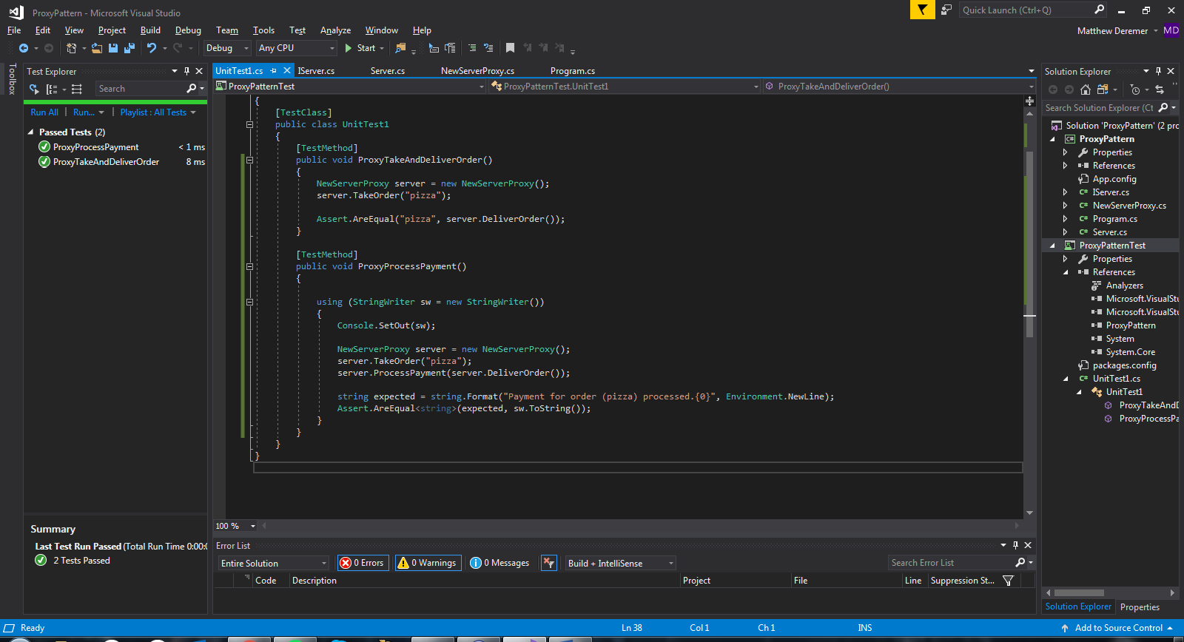

Figure 47: Successful Proxy Pattern Test

As this example of the Proxy Pattern has shown, a proxy can be a useful way to control access to an object. This pattern has many real-world applications such as logins to applications and banking software.

# **References**

[1] E. Freeman, E. Robson, and M. Hendrickson, Head first design patterns. Beijing: OReilly, 2014.

[2] “Composite,” Composite .NET Design Pattern in C# and VB. [Online]. Available: http://www.dofactory.com/net/composite-design-pattern. [Accessed: 11-Dec-2017].

[3] “Proxy pattern,” Wikipedia, 26-Nov-2017. [Online]. Available: https://en.wikipedia.org/wiki/Proxy_pattern. [Accessed: 11-Dec-2017].

[4] BillWagner, “Interfaces (C# Programming Guide),” Microsoft Docs. [Online]. Available: <https://docs.microsoft.com/en-us/dotnet/csharp/programming-guide/interfaces/>. [Accessed: 11-Dec-2017].

[5] T. Point, “Design Patterns State Pattern,” www.tutorialspoint.com, 15-Aug-2017. [Online]. Available: <https://www.tutorialspoint.com/design_pattern/state_pattern.htm>. [Accessed: 11-Dec-2017].